Lab: How to configure SNMPv3 (DAYUTH THY)
323
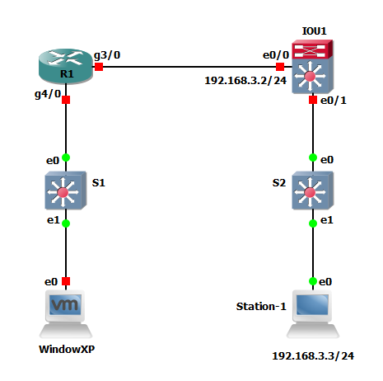
PC: with PowerSNMP Free Manager
Configuration on Router (Agent side):
!===========================================================================
ip access-list standard PERMIT-SNMP
permit 192.168.1.0 0.0.0.255
Exit
snmp-server engineID local 0000000003
snmp-server group SNMP-G1 v3 priv write SNMP-RW access PERMIT-SNMP
snmp-server view SNMP-RW iso included
snmp-server host 192.168.1.3 version 3 priv SNMP-Admin
snmp-server user SNMP-Admin SNMP-G1 v3 auth sha authpass priv aes 128 pripass
snmp-server enable traps
End
!===========================================================================
R2(config)#snmp-server group SNMP-G1 v3 ?
auth group using the authNoPriv Security Level
noauth group using the noAuthNoPriv Security Level
priv group using SNMPv3 authPriv security level
--------------------------------------
SNMP-Admin: is the username
SNMP-G1: is the group name
authpass: is the password for authentication
pripass: is the password for encryption

!Verify
R2#sh run | s snmp
mmi snmp-timeout 180
snmp-server engineID local 0000000003
snmp-server group SNMP-G1 v3 priv write SNMP-RW access PERMIT-SNMP
snmp-server view SNMP-RW iso included
snmp-server enable traps snmp authentication linkdown linkup coldstart warmstart
snmp-server enable traps vrrp
snmp-server enable traps flowmon
snmp-server enable traps ds1
snmp-server enable traps tty
snmp-server enable traps eigrp
snmp-server enable traps ospf state-change
snmp-server enable traps ospf errors
snmp-server enable traps ospf retransmit
snmp-server enable traps ospf lsa
snmp-server enable traps ospf cisco-specific state-change nssa-trans-change
snmp-server enable traps ospf cisco-specific state-change shamlink interface
snmp-server enable traps ospf cisco-specific state-change shamlink neighbor
snmp-server enable traps ospf cisco-specific errors
snmp-server enable traps ospf cisco-specific retransmit
snmp-server enable traps ospf cisco-specific lsa
snmp-server enable traps xgcp
snmp-server enable traps isdn call-information
snmp-server enable traps isdn layer2
snmp-server enable traps isdn chan-not-avail
snmp-server enable traps isdn ietf
snmp-server enable traps ethernet cfm cc mep-up mep-down cross-connect loop conf ig
snmp-server enable traps ethernet cfm crosscheck mep-missing mep-unknown service -up
snmp-server enable traps ethernet evc status create delete
snmp-server enable traps diameter
snmp-server enable traps auth-framework sec-violation auth-fail
snmp-server enable traps trustsec-sxp conn-srcaddr-err msg-parse-err conn-config -err binding-err conn-up conn-down binding-expn-fail oper-nodeid-change binding- conflict
snmp-server enable traps aaa_server
snmp-server enable traps atm subif
snmp-server enable traps bfd
snmp-server enable traps bgp cbgp2
snmp-server enable traps bstun
snmp-server enable traps cef resource-failure peer-state-change peer-fib-state-c hange inconsistency
snmp-server enable traps memory bufferpeak
snmp-server enable traps cnpd
snmp-server enable traps config-copy
snmp-server enable traps config
snmp-server enable traps config-ctid
snmp-server enable traps dial
snmp-server enable traps dlsw
snmp-server enable traps dsp card-status
snmp-server enable traps dsp oper-state
snmp-server enable traps dsp video-usage
snmp-server enable traps dsp video-out-of-resource
snmp-server enable traps entity-ext
snmp-server enable traps entity
snmp-server enable traps fru-ctrl
snmp-server enable traps resource-policy
snmp-server enable traps frame-relay multilink bundle-mismatch
snmp-server enable traps frame-relay
snmp-server enable traps frame-relay subif
snmp-server enable traps hsrp
snmp-server enable traps ipmobile
snmp-server enable traps ipmulticast
snmp-server enable traps isis
snmp-server enable traps mempool
snmp-server enable traps mpls traffic-eng
snmp-server enable traps mpls fast-reroute protected
snmp-server enable traps mpls rfc ldp
snmp-server enable traps mpls ldp
snmp-server enable traps msdp
snmp-server enable traps mvpn
snmp-server enable traps pim neighbor-change rp-mapping-change invalid-pim-messa ge
snmp-server enable traps pppoe
snmp-server enable traps cpu threshold
snmp-server enable traps nhrp nhs
snmp-server enable traps nhrp nhc
snmp-server enable traps nhrp nhp
snmp-server enable traps nhrp quota-exceeded
snmp-server enable traps rsvp
snmp-server enable traps ipsla
snmp-server enable traps stun
snmp-server enable traps l2tun session
snmp-server enable traps l2tun pseudowire status
snmp-server enable traps pw vc
snmp-server enable traps waas
snmp-server enable traps event-manager
snmp-server enable traps firewall serverstatus
snmp-server enable traps ospfv3 state-change
snmp-server enable traps ospfv3 errors
snmp-server enable traps pki
snmp-server enable traps gdoi gm-start-registration
snmp-server enable traps gdoi gm-registration-complete
snmp-server enable traps gdoi gm-re-register
snmp-server enable traps gdoi gm-rekey-rcvd
snmp-server enable traps gdoi gm-rekey-fail
snmp-server enable traps gdoi ks-rekey-pushed
snmp-server enable traps gdoi gm-incomplete-cfg
snmp-server enable traps gdoi ks-no-rsa-keys
snmp-server enable traps gdoi ks-new-registration
snmp-server enable traps gdoi ks-reg-complete
snmp-server enable traps ike policy add
snmp-server enable traps ike policy delete
snmp-server enable traps ike tunnel start
snmp-server enable traps ike tunnel stop
snmp-server enable traps ipsec cryptomap add
snmp-server enable traps ipsec cryptomap delete
snmp-server enable traps ipsec cryptomap attach
snmp-server enable traps ipsec cryptomap detach
snmp-server enable traps ipsec tunnel start
snmp-server enable traps ipsec tunnel stop
snmp-server enable traps ipsec too-many-sas
snmp-server enable traps ethernet cfm alarm
snmp-server enable traps ccme
snmp-server enable traps srst
snmp-server enable traps rf
snmp-server enable traps bulkstat collection transfer
snmp-server enable traps mpls vpn
snmp-server enable traps voice
snmp-server enable traps dnis
snmp-server enable traps vrfmib vrf-up vrf-down vnet-trunk-up vnet-trunk-down
snmp-server host 192.168.111.3 version 3 priv SNMP-Admin
How to configure on PC:
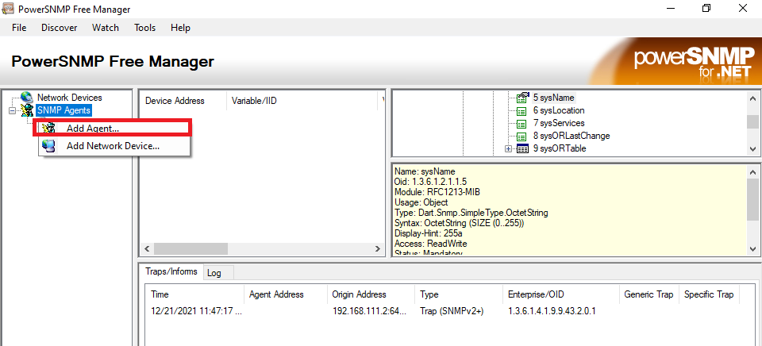
Right-click on SNMP Agents > Add Agent…
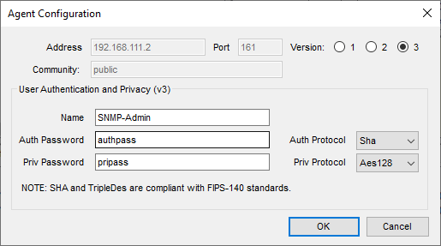
Address: 192.168.111.2 is the IP address of SNMP agent installed
Port: 161, Version: 3
Name: is username
Auth Password: is the password of Authentication, Auth Protol: according to router
Priv Password: is the password of encryption, Priv Protocl: match to router configuration
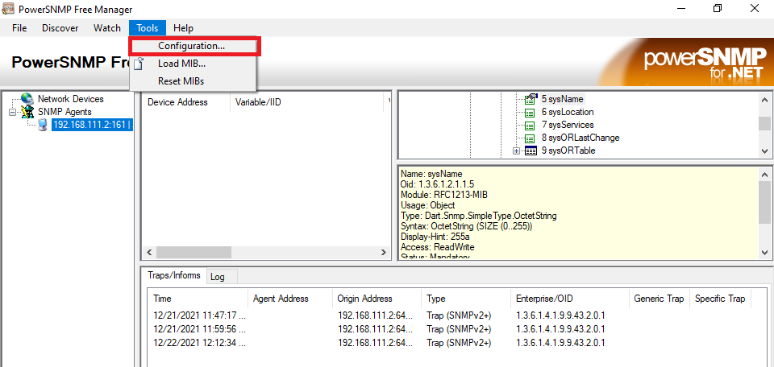
To configure traps:
Click Tool > Configuration
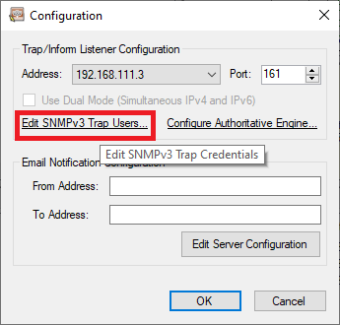
Click on Edit SNMPv3 Trap Users…
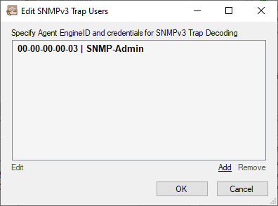
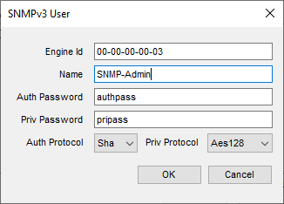
Click Add

Engin ID from command: snmp-server engineID local 0000000003
Name: is the username
Auth Password: is the password of Authentication,
Priv Password: is the password of encryption
Auth Protol: according to router
Priv Protocl: match to router configuration

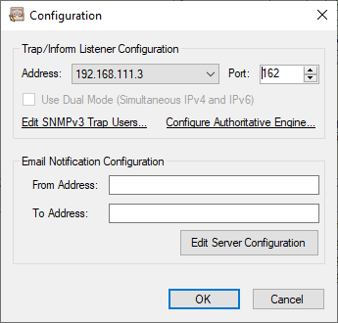

Address: is IP of PC to listen to trap, Port change to 192 and click OK

To test:
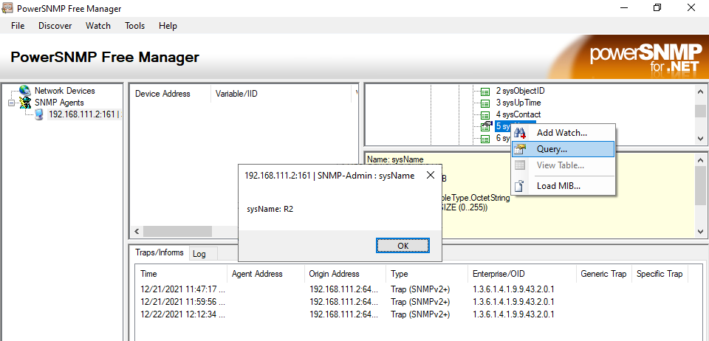
Right click on SysName > Query…
The result of the query is R2, which is the name of the router
Add a loopback interface on R2 by using command below:
R2(config)#interface lo2
R2(config-if)#
*Dec 22 08:30:33.395: %LINEPROTO-5-UPDOWN: Line protocol on Interface Loopback2, changed state to up
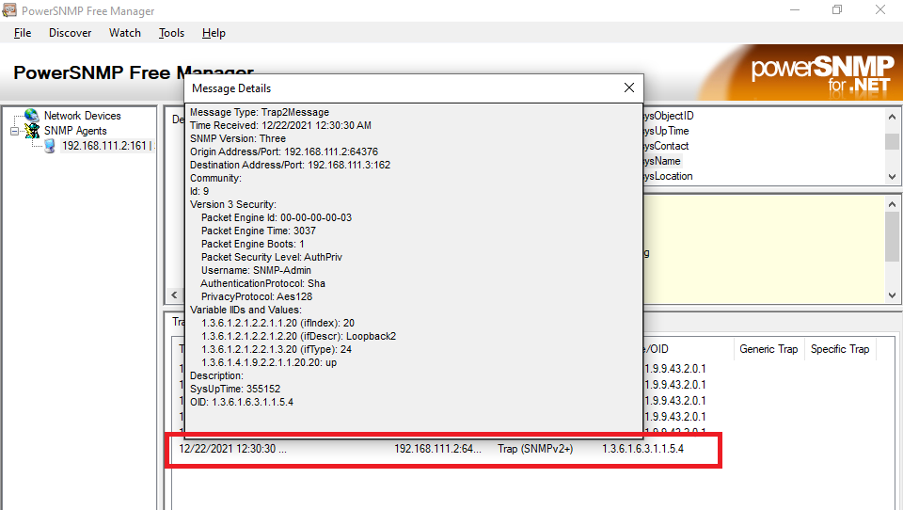
Double click on the Trap message under the Traps/Informs Tab of the bottom display pane, it show the Loopback2 is up state
Verify if SNMP traps has been sent from Router:
R2#sh snmp
Chassis: 2048003
14 SNMP packets input
0 Bad SNMP version errors
0 Unknown community name
0 Illegal operation for community name supplied
0 Encoding errors
6 Number of requested variables
0 Number of altered variables
6 Get-request PDUs
0 Get-next PDUs
0 Set-request PDUs
0 Input queue packet drops (Maximum queue size 1000)
20 SNMP packets output
0 Too big errors (Maximum packet size 1500)
0 No such name errors
0 Bad values errors
0 General errors
0 Response PDUs
6 Trap PDUs
SNMP Dispatcher:
queue 0/75 (current/max), 0 dropped
SNMP Engine:
queue 0/1000 (current/max), 0 dropped
0 Unknown Security Models
0 SNMP Invalid Messages
1 SNMP Unknown PDU handlers
0 Unsupported Security Level
4 Unknown User Names
3 Unknown EngineIDs
0 Not In Time Windows
6 messages have been sent
0 Wrong MD5 or SHA Digests
0 Decryption Errors

SNMP logging: enabled
Logging to 192.168.111.3.162, 0/10, 6 sent, 0 dropped.
R2#conf t
Enter configuration commands, one per line. End with CNTL/Z.
R2(config)#in
R2(config)#interface lo
R2(config)#interface lo2
R2(config-if)#sh
R2(config-if)#no
*Dec 22 08:38:11.443: %LINK-5-CHANGED: Interface Loopback2, changed state to administratively down
*Dec 22 08:38:12.448: %LINEPROTO-5-UPDOWN: Line protocol on Interface Loopback2, changed state to down
R2(config-if)#no sh
R2(config-if)#end
R2#
R2#sh snmp
*Dec 22 08:38:17.117: %SYS-5-CONFIG_I: Configured from console by console
R2#sh snmp
Chassis: 2048003
14 SNMP packets input
0 Bad SNMP version errors
0 Unknown community name
0 Illegal operation for community name supplied
0 Encoding errors
6 Number of requested variables
0 Number of altered variables
6 Get-request PDUs
0 Get-next PDUs
0 Set-request PDUs
0 Input queue packet drops (Maximum queue size 1000)
23 SNMP packets output
0 Too big errors (Maximum packet size 1500)
0 No such name errors
0 Bad values errors
0 General errors
0 Response PDUs
9 Trap PDUs
SNMP Dispatcher:
queue 0/75 (current/max), 0 dropped
SNMP Engine:
queue 0/1000 (current/max), 0 dropped
0 Unknown Security Models
0 SNMP Invalid Messages
1 SNMP Unknown PDU handlers
0 Unsupported Security Level
4 Unknown User Names
3 Unknown EngineIDs
10 messages have been sent after sh and no shut has been issued on Loopback 2 interface
0 Not In Time Windows
0 Wrong MD5 or SHA Digests
0 Decryption Errors

SNMP logging: enabled
Logging to 192.168.111.3.162, 0/10, 10 sent, 0 dropped.
R2#
*Dec 22 08:38:18.067: %LINK-3-UPDOWN: Interface Loopback2, changed state to up
*Dec 22 08:38:19.072: %LINEPROTO-5-UPDOWN: Line protocol on Interface Loopback2, changed state to up

Link to download: https://powersnmp-free-manager.software.informer.com/download/

